Data Visualisation 2 Proposal
1. Domain
- The focus of this visualization is on earthquake activity across Australia.
2. Why?
- Users may want to learn how earthquake activity has changed over time to identify historical patterns and trends in seismic events.
- Users may be interested in seeing which areas of Australia experience the most frequent earthquakes, helping to identify high-risk zones.
- The visualization can help educate Australians about their country's susceptibility to earthquakes, raising awareness and promoting preparedness for seismic events.
3. Who?
- With the recent ‘earthquake swarm’ in the Hunter region of New South Wales which recorded over 30 earthquakes in September 2024, this visualisation is for Australians who are curious about seismic activity. The visualization will help them understand the frequency and impact of these events.
4. What?
Dataset: Geoscience Australia (Government Data)
Link: https://earthquakes.ga.gov.au/
Size: 2.394 MB
Description:
- All Australian Earthquake data from Jan 2000 – Sep 2024
- The original dataset contains 13511 observations and 38 attributes (columns) including:
  - Longitude, latitude, Magnitude, Depth, Date, Felt Reports, Station Name (that detected it), Station Distance (from the estimated earthquake), etc.
4. Design ideas
Dot Map: An interactive map of Australia that displays earthquake activity using layered data.
- Earthquake Data: Plot earthquakes using color-coded circles or markers. Different colors or sizes can represent various magnitudes or depths.
- Filters: Include interactive filters to view earthquakes by date range, magnitude, or depth. This allows users to see trends over time or focus on specific regions.
Line Graph/Bar Chart: A timeline graph that illustrates the frequency and magnitude of earthquakes over time.
Heat Map Calendar: a calendar heatmap that shows earthquake frequency on a monthly or daily basis.
Bubble Chart: A bubble chart that displays earthquakes using bubbles where size and color represent magnitude and frequency.

Search Input:
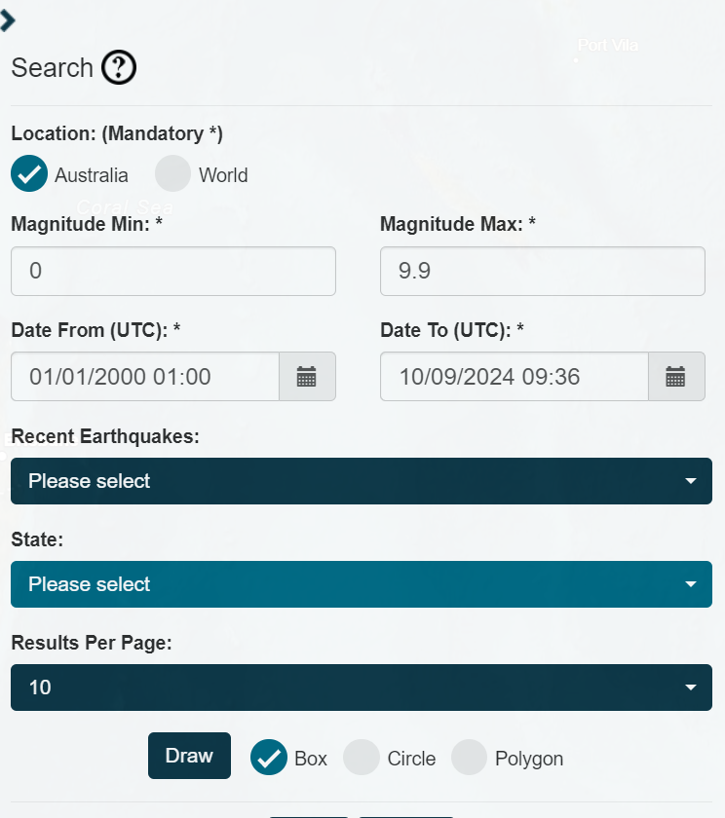
Search criteria: located_in_australia='Y' AND preferred_magnitude>=0 AND preferred_magnitude<=9.94 AND origin_time BETWEEN 2000-01-01T01:00:00Z AND 2024-09-10T09:35:00Z

